TASK 5 – EXAMINE SYSTEM CALLS

1. Aim
To understand system calls and demonstrate how a user-level program communicates with the operating system kernel using file-related system calls.

2. Introduction
A system call is a mechanism through which a user program requests services from the operating system kernel.
Applications cannot directly access all hardware resources. Therefore, they use system calls to perform operations such as creating files, reading data, writing data and managing processes.
System calls provide an interface between user applications and the operating system.

3. Categories of System Calls

A. Process Control
Process control system calls are used to create, execute and terminate processes.
Examples:
- fork()
- exec()
- wait()
- exit()

B. File Management
File management system calls are used to create, open, read, write and close files.
Examples:
- open()
- read()
- write()
- close()

C. Device Management
These system calls are used to access and control hardware devices.
Examples:
- ioctl()
- read()
- write()

D. Information Maintenance
These system calls provide information about processes and the operating system.
Examples:
- getpid()
- getuid()
- uname()

E. Communication
Communication system calls allow processes to exchange information.
Examples:
- pipe()
- socket()
- send()
- recv()

F. Protection
Protection system calls manage permissions and access control.
Examples:
- chmod()
- chown()
- access()

4. Working of a System Call
The working process of a system call involves the following steps:
- A user application requests an operating system service.
- The application calls a library function.
- The system-call interface transfers control to the kernel.
- The CPU switches from user mode to kernel mode.
- The kernel performs the requested operation.
- The result is returned to the application.
- The CPU switches back to user mode.

5. System Call Parameter Passing
System-call parameters can be passed in three major ways.
- Through CPU registers: Parameters are stored in processor registers.
- Through a memory block: Parameters are stored in memory and a register contains the address.
- Through the program stack: Parameters are pushed onto the stack and accessed by the kernel interface.
These methods help the operating system receive the required information.

6. Practical Implementation

Program: Demonstration of File System Calls
The following C program creates a file, writes information into it, reads the information and closes the file.
File Name: system_calls.c
#include <stdio.h>
#include <fcntl.h>
#include <unistd.h>
#include <string.h>

int main()
{
char buffer[100];

int fd = open("hospital.txt",
O_CREAT | O_WRONLY | O_TRUNC, 0644);

if (fd < 0) {
perror("open");
return 1;
}

char message[] = "Smart Hospital System Calls Demo\n";

write(fd, message, strlen(message));
close(fd);

fd = open("hospital.txt", O_RDONLY);

if (fd < 0) {
perror("open");
return 1;
}

ssize_t bytes = read(fd, buffer, sizeof(buffer) - 1);

if (bytes < 0) {
perror("read");
close(fd);
return 1;
}

buffer[bytes] = '\0';

printf("File content: %s", buffer);
printf("Bytes read: %zd\n", bytes);

close(fd);

return 0;
}

7. Compilation and Execution
The program was compiled and executed in Kali Linux using GCC.
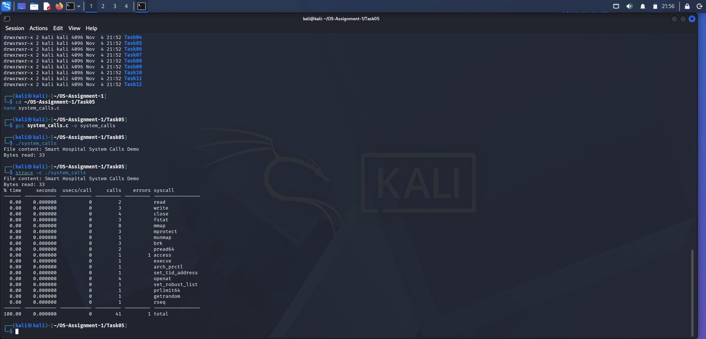
Compilation command:
gcc system_calls.c -o system_calls
Execution command:
./system_calls

Actual Output
File content: Smart Hospital System Calls Demo
Bytes read: 33

8. System Call Tracing Using strace
The strace utility is used to observe the system calls made by a program.
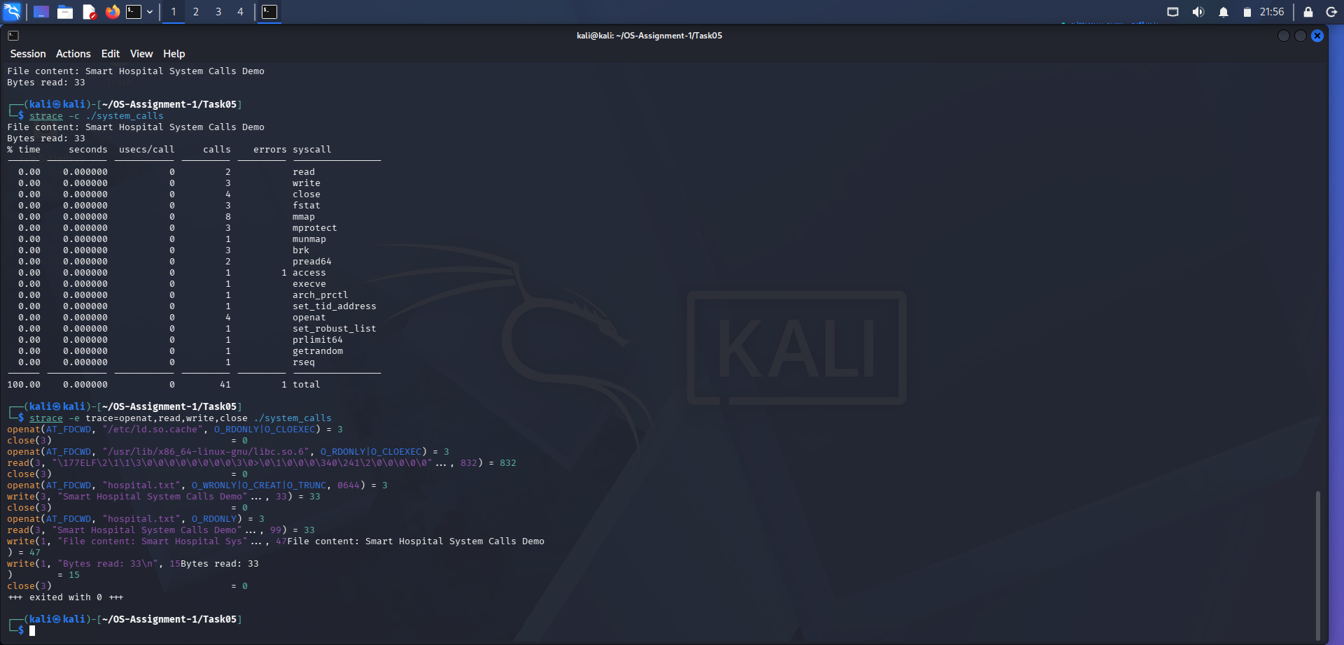
Command:
strace -c ./system_calls
The actual experiment reported 41 total system calls, including runtime and library-related operations.
System Call | Number of Calls
read | 2
write | 3
close | 4
openat | 4
Total system calls | 41
To observe individual system calls, the following command was used:
strace -e trace=openat,read,write,close ./system_calls
Important observations from the actual output:
write(3, "Smart Hospital System Calls Demo"..., 33) = 33

read(3, "Smart Hospital System Calls Demo"..., 99) = 33

+++ exited with 0 +++
The output confirms that the file was successfully opened, written, read and closed.
Linux uses openat() internally for the file-opening operations in this experiment.

9. Alternative Concept and Complexity Analysis
An alternative method is to use standard C library functions such as fopen(), fread() and fwrite().
These functions provide a higher-level interface for file operations and may use internal buffering to reduce system calls.
Comparison:
Feature | System Calls | Library Functions
Level | Low-level | High-level
Control | More direct | Easier to use
Buffering | Generally managed by application | Library may provide buffering
Complexity | More detailed | Simpler
Examples | read(), write() | fread(), fwrite()
Time Complexity: O(n), where n is the number of bytes processed.
Space Complexity: O(b), where b is the buffer size.

10. Conclusion
The experiment successfully demonstrated the use of Linux system calls through a C program. The program created a file, wrote 33 bytes of data and read the same information successfully.
The strace utility helped observe system calls such as openat(), read(), write() and close().
Therefore, system calls provide an important communication interface between user applications and the operating system kernel.

